C PROAGRAMMING DAY 1:

1.THE PROGRAM TO DISPLAY

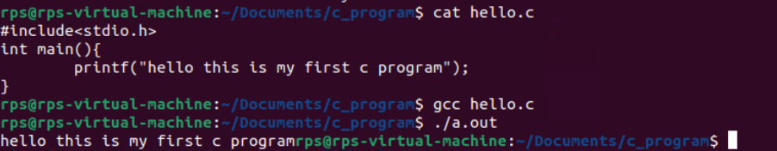

2.THE PROGRAM TO ADD TO VARIABLE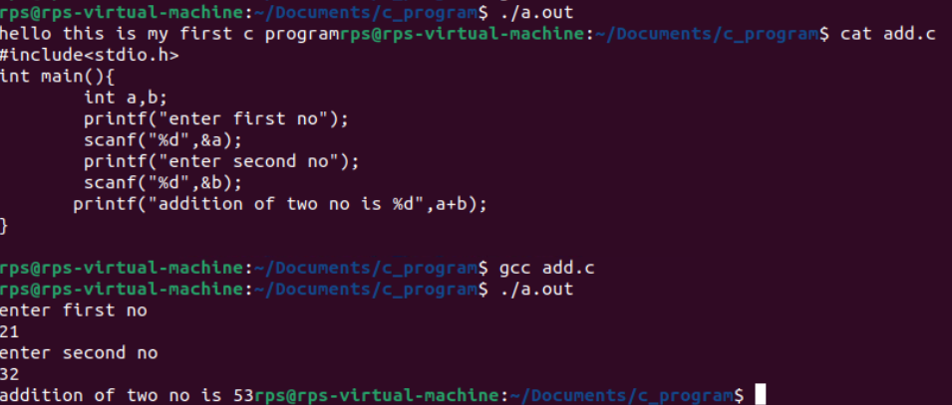

3.THE PROGRAM TO DISPLAY DATE AND TIME

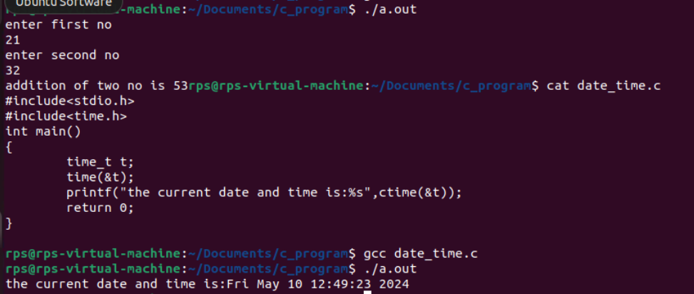

4.THE PROGRAM TO DISPLAY NAME 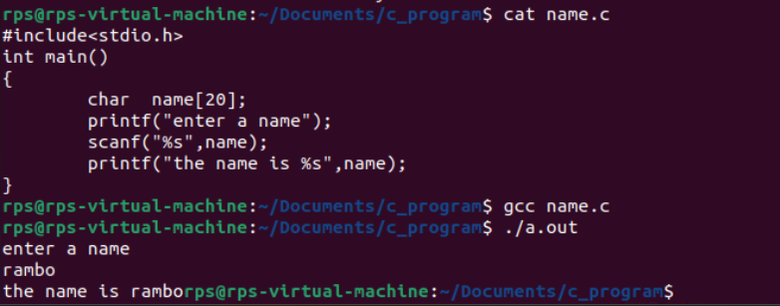

5.PROGRAM TO ADD 2 NO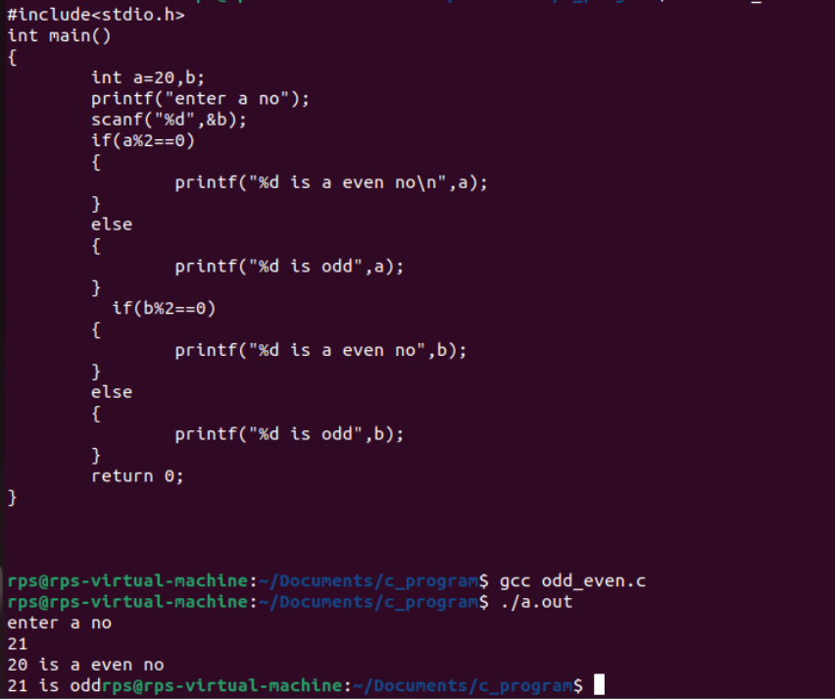

6.PROGRAM TO PERFORM REVERSE

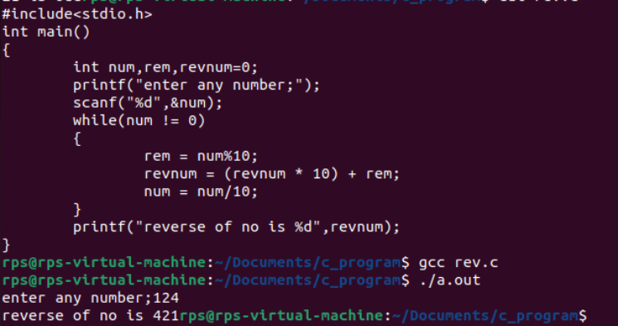

7.PROGRAM TO DEMONSTRATE SIZE OF

